[K-5] Building a Culture of Math Learning Session 7 Facilitator’s Guide

Summary
Effective teaching of mathematics requires cultivating a culture of math learning within the classroom - this culture encourages students to take academic risks, to persevere when content becomes challenging, to utilize a myriad of mathematical tools and models to approach new problems, to share their own thinking, and to offer feedback on the thinking of others. To cultivate this kind of culture, teachers must model through words and actions the importance of grappling with content to build a deep understanding; they must equip students with the content knowledge and problem solving tools to find multiple pathways to a given solution; and they must facilitate regular opportunities for students to engage in the practices of mathematics, including analyzing their own misconceptions and refining their approaches as part of the learning process.

Throughout this content cycle, teachers will explore these instructional moves and connect them directly to the mathematical content and standards for mathematical practices within the Kentucky Academic Standards (KAS) for Mathematics. While this content cycle will do a deep dive of the 3 Standards for Mathematical Practice indicated below, the KAS for Mathematics require teachers to implement all 8 Standards for Mathematical Practice. To support teachers in elevating different SMPs during their instruction, the KAS for Mathematics tag relevant MPs to every content standard. The inclusion of those tagged MPs does NOT mean those are the only ways students can engage in the practices while learning that content. The inclusion of tagged MPs also doesn’t mean that those practices automatically happen throughout instruction on that content standard. How instruction is designed will determine how students engage with the content. This content cycle will support educators in purposefully planning and designing instruction to provide students with opportunities to engage in the practice standards while engaging with the content standards.

This content cycle focuses specifically on:
- SMP1. Make sense of problems and persevere in solving them
- SMP4. Model with mathematics
- SMP3. Construct viable arguments and critique the reasoning of others

See the Mathematics Professional Learning Modules for additional learning around the Standards for Mathematical Practice or for guidance/support with implementing the KAS for Mathematics.

Essential Questions
- How do the Standards of Mathematical Practice support teachers in creating and sustaining a culture of learning in math classrooms?
- How can teachers explicitly introduce and authentically incorporate the Standards of Mathematical Practice within their instruction?
- How can teachers create a “culture of error” where students feel comfortable taking academic risks, struggling through high-quality tasks and discussing their misconceptions to advance their own learning?
- Specifically, how can an emphasis on problem-solving (SMP 1), modeling to understand “concepts before procedures” (SMP 4) and justification of answers (SMP 3) create an environment where students are encouraged to own their own learning?

Enduring Understandings
- Teachers should communicate that perseverance, which requires a willingness to take risks and make mistakes, is a critical part of the learning process.
- In order for students to own their own learning, teachers intentionally design instruction which places equal value on the development of mathematical content and mathematical practices.
- True conceptual understanding of math comes from connecting multiple representations (concrete, representational/pictorial, and abstract).
- To build deep and enduring understanding of math, teachers must place emphasis on the “how” and “why” and push students to justify their answers,
- Meaningful teacher and peer feedback allow for students to monitor their progress toward learning outcomes and provides students with opportunities to reflect on their own learning.

Key Components of Cycle
The Learning Cycle includes the following components to support shifts in instruction:
- Shared Learning: Learning sessions where teachers learn new knowledge and skills aligned to the topic of the content cycle. This might be designed in a variety of ways, including reading and discussing an article, studying a classroom video or doing some group practice of a particular planning component.
- Planning & Practice: Opportunities for teachers to apply the content they are learning within this content cycle to review/revise classroom instruction. This could include analyzing units/lessons using tools to evaluate alignment to the KAS for Mathematics, rehearsing lessons, watching and reflecting on videos of their classroom practice, etc.
- Student Progress Monitoring: This is an opportunity for teachers to examine student progress aligned to the topic of the cycle. This can include formative student work analysis, end of unit assessments, culminating tasks, etc.

Over the course of this 12-week learning cycle, teachers will:
- Examine instructional materials and tasks using the KAS for Mathematics and supporting resources;
- Consider the implications of these materials as they relate to changes in both teacher planning and practice;
- Engage in lesson study, practice in content delivery and peer-feedback, and reflect on progress by regularly revisiting goals and analyzing student data

Note that these components do not necessarily happen in a perfect rhythm. For example, depending on the content, there may be several shared learning sessions before a planning & practice, or there may be several cycles of shared learning and planning & practice before student progress monitoring.

Session | Type of Learning | Objective(s) | Supporting KAS Resources | Assessment of Learning
Session 7 | Shared Learning Focusing on SMP 4 | - Analyze specific teacher planning and instructional moves around incorporating SMP 4 within the lesson and the impact on student learning | - KAS for Mathematics  - Engaging the SMPs: Look fors and Question Stems | - Session tasks: Create a student exemplar, video observation notes  - Self-reflection

Preparation:
This Facilitator’s Guide is designed to accompany
- [K-5] BCML Session 7 PowerPoint
Participants should be given access to the following documents to engage in the learning for this session:
- [K-5] BCML Session 7 Handout 1
- [K-5] BCML Session 7 Handout 2

Session Agenda Time (75 min)
- Slides 1 - 4: Welcome, norms, objectives & agenda (10 min)
- Slides 5-8: Connection to Prior Learning: SMP 4 (12 min)
- Slide 9-10: Read the standard/clarifications, create a student exemplar for an aligned task, task share out (15 min)
- Slides 11-13: Video observation, video share out, instruction share out (17 min)
- Slide 14: Connection to Equity (4 min)
- Slide 15: Criteria for Success (5 min)
- Slide 16 - 18: Reflection, closing whip around, what’s next (12 min)
Facilitator Notes | Accompanying Slide
Slide 1:  (1 min) Welcome teachers to the session. | 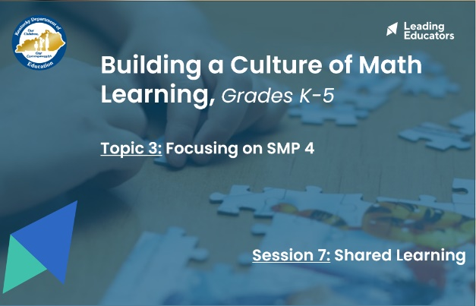
Slide 2:  (2 min) Facilitator says:  - “Here you’ll see our 12-week arc of learning. Can I have someone read out our guiding principle in the yellow box?”  - “In green, you’ll see our four major topics of learning. For each topic of learning, we’ll engage in a three-week learning cycle that will include a shared learning session, a planning and practice session, and a student progress session. Our first topic of learning included an overview of all 8 Mathematical Practices. In the next 3 topics, we’ll narrow our focus to cover just one SMP at a time so we can better internalize and apply our learning. As you’ll see, the three SMPs we will focus on are:  - Standard for Mathematical Practice 1: Make sense of problems and persevere in solving them.  - Standard for Mathematical Practice 4: Model with mathematics.  - Standard for Mathematical Practice 3: Construct viable arguments and critique the reasoning of others.”  - “While this content cycle will do a deep dive of 3 Standards for Mathematical Practice, the KAS for Mathematics require teachers to implement all 8 Standards for Mathematical Practices. To support teachers in elevating different SMPs during their instruction, the KAS for Mathematics tag relevant SMPs to every content standard. The inclusion of those tagged SMPs does NOT mean those are the only ways students can engage in the practices while learning that content. It also doesn’t mean that throughout instruction on that content standard those practices automatically happen. How instruction is designed will determine how students engage with the content. See the KY Standards Mathematics Professional Learning Modules for guidance.”  - [CLICK for animation] You’ll see that today we are continuing our learning with Topic 3 - Focusing on SMP 4: Model with Mathematics.  - [CLICK for animation] Our first session in this topic will be shared learning, where we can build a bank of common experiences and language to use throughout this content cycle. | 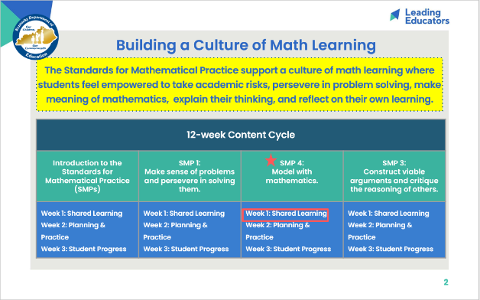
Slide 3:
(5 min) Review team norms and/or facilitate a quick team connector/icebreaker.

Slide 4:  (2 min) Ask teachers to popcorn out the objectives and agenda. Facilitator says:  - “By having a concrete example of what SMP 4 looks like (in terms of teacher moves and impact on student learning), we’ll be better able to consider how to incorporate this SMP into our practice. Similar to our last shared learning session (Session 4 - Focusing on SMP 1), we’ll be using our annotated Lesson Planning tool to help us engage in “intellectual prep work” which includes considering the standard context and completing the same task seen in the video. This way, we’ll flex our own skills of “doing the math” and “experiencing the learning” which will give us a better lens for the video observation. | 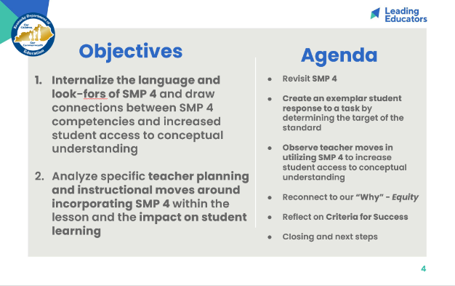
Slide 5:
(< 30 sec) Facilitator says:
- “Let’s preview the criteria for success that will guide our learning for this entire topic. Take 2 silent minutes to mark up the MTPs that will support our students in engaging with the focus SMP on Handout 1 - Page 5.”

(2 min) Teachers take 2 minutes to read criteria for success.

(< 30 sec) Facilitator says:
- With a partner, draw parallels between the MTPs (what teachers are doing) and the SMPs (what students are doing as a result).”

(2 min) Teachers take 2 minutes to read criteria for success.
*Note: Listen for and reinforce these key ideas...
- There are many connections between the MTPs are SMPs. Teachers may highlight connects between:
  - MTP 2/3 and SMP 4 - In order for students to utilize multiple representations, they must be given rigorous tasks around key mathematical concepts. Teachers must model how these representations connect to one another.
  - MTP 5/8 and SMP 1 - In order for student struggle to be productive, teachers must ensure that students have differentiated access points to the key mathematics of the lesson so that all students can engage in learning. By asking purposeful questions and adjusting instructional supports based on student answers, teachers can ensure that all students can make sense of grade-level tasks.
- This list of connections is not exhaustive; teachers may find other connections and justify their own rationale for how those teacher practices model, encourage, and support students in engaging with the SMPs.

(< 30 sec) Facilitator says:
- “As we engage in shared learning today, continue to return to these criteria and consider how today’s learning is supporting your growth and progress in these indicators.”

Slide 6:  (1 min) Facilitator says:  - “We’ll take 2 minutes to review our takeaways on SMP 3. You can revisit your notes from our first shared learning session (Session 1) or revisit the KAS for Mathematics “Engaging the SMPs: Look-fors & Question stems”.  (2 min) Teachers jot down their reflections on post-it notes. | 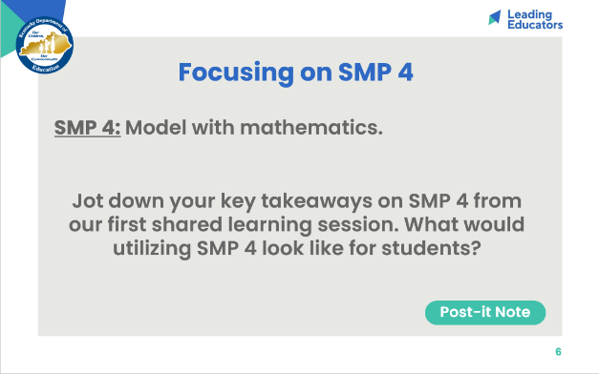
Slide 7:  (2 min) Have 1 or 2 teachers share.  (2 min) Connect teachers shared ideas and iterate the any bullets that may have been missed.  *Note: Listen for and reinforce these key ideas...  - The statements above come from the KAS for Mathematics - Standards for Mathematical Practice. The above statements have been highlighted from longer text, which can be found here (pages 13-14):  - “Mathematically proficient students can apply the mathematics they know to solve problems that arise in everyday life. In early grades, this might be as simple as writing an addition equation to describe a situation. In middle grades, a student might apply proportional reasoning to plan a school event or analyze a problem in the community. By high school, a student might use geometry to solve a design problem or use a function to describe how one quantity of interest depends on another. Mathematically proficient students who can apply what they know are comfortable making 14 assumptions and approximations to simplify a complicated situation, realizing that these may need revision later. They are able to identify important quantities in a practical situation and map their relationships using such tools as diagrams, two-way tables, graphs, flowcharts and formulas. They can analyze those relationships mathematically to draw conclusions. They routinely interpret their mathematical results in the context of the situation and reflect on whether the results make sense, possibly improving the model if it has not served its purpose.” | 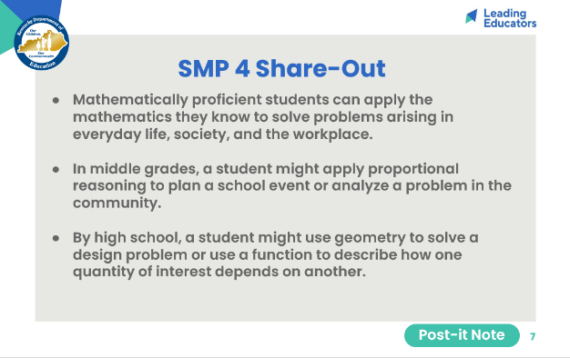
Slide 8:  (3 min) Connect teachers shared ideas and iterate the any bullets that may have been missed.  *Note: Listen for and reinforce these key ideas...  - Teachers and students must have common understanding of language around modeling with mathematics - modeling with mathematics means providing students with concrete, representational, and abstract (CRA) methods to model real-world situations. Often, teachers abandon concrete and representational methods once students have learned an algorithm, because of efficiency. However, teachers should be pushed to connect CRA approaches fluidly, not just linearly from concrete to representational to abstract. To truly engage with the targets of the standards, students must be able to see connections among the methods instead of viewing them as separate, unrelated “strategies.”  - For students to fully engage in modeling with mathematics, they will employ other SMPs as well. For example, students will need to make sense of problems and persevere in solving them (SMP 1) and often will need to reason abstractly and quantitatively (SMP 2) in order to decontextualize a real world problem to represent it as mathematical model and vice versa. As tasks get more complex, students should also be engaged in constructing viable arguments and critiquing the reasoning of others (SMP 3). | 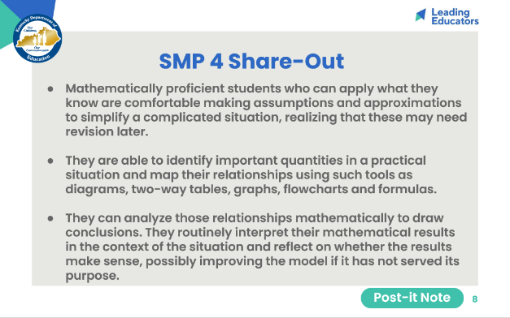
Slide 9:  (2 min) Connect teachers shared ideas and iterate the any bullets that may have been missed. | 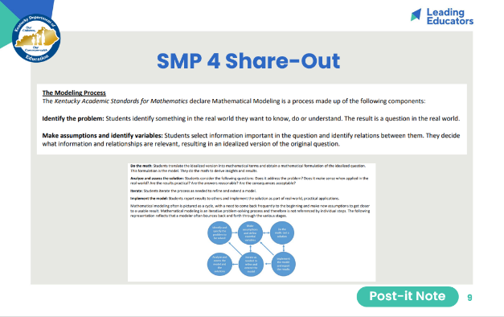
Slide 10:  (2 min) Facilitator says:  - “Last topic, we watched videos where teachers incorporated a variety of SMPs in their lesson and turned a particular eye toward noting evidence of SMP 1. Today, we’re going to zone in and look for evidence of SMP 4 specifically. Over the course of the year, SMPs 1, 4, and 3 will be our focus SMPs - the ones we’ll practice, reflect on, and refine. While all the SMPs are important, we believe that SMPs 1, 4, and 3 are particularly high leverage - they create a culture where students are willing to take risks and persevere through challenging math, as well as give students the methods to struggle productively as they approach grade-level work/tasks. Ultimately, developing student proficiency in SMPs 1, 4, and 3 will pave the way for our students’ development in mastering other SMPs in the future.”  - “While this content cycle will do a deep dive of 3 Standards for Mathematical Practice, the KAS for Mathematics require teachers to implement all 8 Standards for Mathematical Practices. To support teachers in elevating different SMPs during their instruction, the KAS for Mathematics tag relevant SMPs to every content standard. The inclusion of those tagged SMPs does NOT mean those are the only ways students can engage in the practices while learning that content. It also doesn’t mean that throughout instruction on that content standard those practices automatically happen. How instruction is designed will determine how students engage with the content. See the KY Standards Mathematics Professional Learning Modules for guidance.”  - “Similar to Session 4’s shared learning experience, we’ll use an annotated lesson planning tool to help us internalize the task that we will watch in today’s video.”  - “Because we’re not planning a full lesson, some of the lesson planning tool has been pre-filled or annotated for you already. We’ll be focusing on just the Do the Math, Target of the Standard, and Standards for Mathematical Practice portions of the lesson planning tool.”  (5 min) Facilitator says:  - “Let’s start by reviewing the standard and completing the task, so we can start with ‘the end in mind.’”  - “Please take 5 minutes to complete the Do the Math, Target of the Standard, and Standards for Mathematical Practice portions of the lesson planning tool.”  - “Remember, as we engage with the new KAS for Mathematics, we may need to do additional work to break down the standard before we dive into lesson planning and creating an exemplar student response to an aligned task. Teachers are encouraged to use the Breaking Down a Mathematics Standard tool (also found in the BCML Appendix) to continue to deepen their understanding of content standards.” | 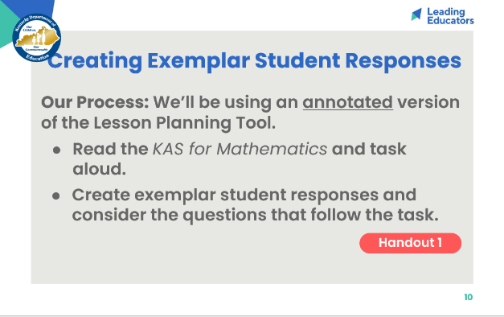
Slide 11:  (8 min) Review the Do the Math, Target of the Standard, and SMP sections on the annotated lesson plan tool. Ask teachers to also consider this guiding question as they share, “What types of methods (concrete, representational, and/or abstract) does your exemplar include? How do those methods support students in accessing the target of the standard presented in the task?”  *Note: Listen for and reinforce these key ideas...  - The target of the standard presented in this task is conceptual understanding. Students are asked to determine if visual representations of fractions (using a variety of shapes) show a value of ½. Since students do not yet know how to find common denominators to create equivalent fractions, exemplar student responses will likely use concrete and/or representational methods to demonstrate understanding.  - Possible exemplars might entail:  - Folding: In this strategy, students fold the figure along the segment that separates the shaded part from the unshaded part and will notice that the shaded part is the same size (and shape) as the unshaded part. For example, this strategy can be used to show that one half is shaded in Figures a, b, e, h, and j. In figures k and l, folding the shape along line of shaded part does not fully cover the other part of the shape, showing that the shaded part does not represent one-half.  - Cutting and rearranging: This concrete method would work well for exploring figure g and d. By cutting the blue, shaded pieces and laying them on top of the unshaded part(s), students would see that the area of the shaded and unshaded parts are the same and therefore equal. We can anticipate student misconceptions for Figure g since folding won’t work in this scenario.  - Facilitators should point teachers toward the Attending to the Standards for Mathematical Practice and clarifications for this standard found on pages 68-69 in the Kentucky Academic Standards document which reiterates: “As [students] partition the line [in addition to figures and bar models] in other ways, they recognize three-sixths is half of the distance to 1 whole, as is 2/4 , ½ , and 4/8 , and reason these fractions are equivalent.” | 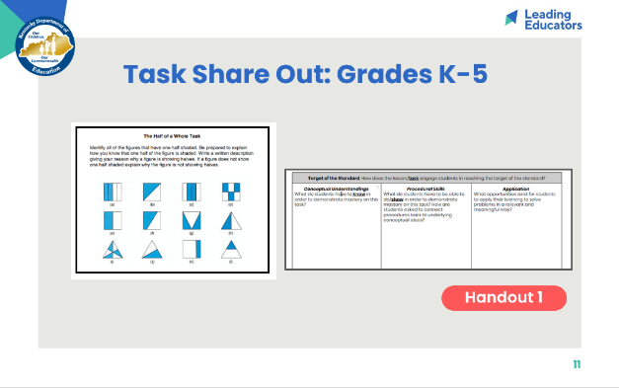
Slide 12:  (1 min) Facilitator says:  - “We’ll likely see evidence of multiple SMPs being taught by the teacher and being utilized by the students because the SMPs work in conjunction and build upon one another. While you’re encouraged to note how the teacher employs multiple SMPs, I do want us to look out for SMP 4 specifically. As you watch, record evidence of how Ms. Brooks incorporates SMP 4 into her lesson. A transcript of the lesson can be found on Handout 2 if you’d like to annotate what Ms. Brooks/students are saying/doing. What evidence do we have of the impact of SMP 4 on student learning?  - “Remember, the video we’re watching isn’t perfect instruction - Try to focus on what’s effective about the teacher moves we see here. Afterward, we’ll share our own experiences with this practice and discuss ways we can continue to evolve and refine our usage of the SMPs.”  (6 min) Play video clip (entire clip).  (2 min) Facilitator says:  - “Take another 2 minutes to finish up your notes. Again, similar to our last video observation, I’d like you to consider the “behind the scenes” prep and planning Ms. Brooks might have done in order to incorporate SMP 4 into this lesson. Finding opportunities to amplify SMPs during our lesson doesn’t just happen; we need to effectively plan ahead to include them and make sure that using the SMPs within that lesson is a meaningful experience for our students. While we don’t see a lesson plan or debrief about her planning process, what prep work can infer Ms. Brooks did to successfully connect this specific lesson’s objectives with SMP 4? You can include those notes in the box below the chart.” | 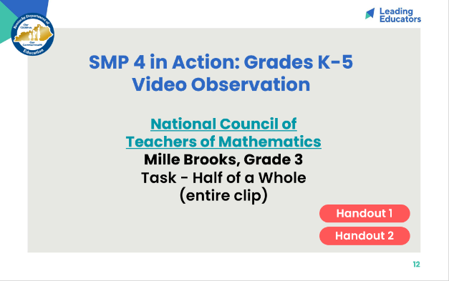
Slide 13:  (5 min) Facilitator says:  - “Let’s visit our observation notes and the planning steps we’ve inferred from the video.”  *Note: Listen for and reinforce these key ideas…  - Ms. Brooks helps make connections to the mathematics and the different methods by highlighting the concept that one-half is represented when there are an equal number of shaded and unshaded parts. She makes this connection to the folding method used with another image (SMP 4)  - Ms. Brooks helps to maximize student ownership of the learning by asking a student to share her reasoning with her teammates. The student was asked to convince her peer’s why the image represents one-half - we can see SMP 1, 4, and 3 being utilized in this instructional move.  (1 min) Facilitator says:  - “In terms of process, how did using the annotated lesson planning tool impact your lens going into the observation?” | 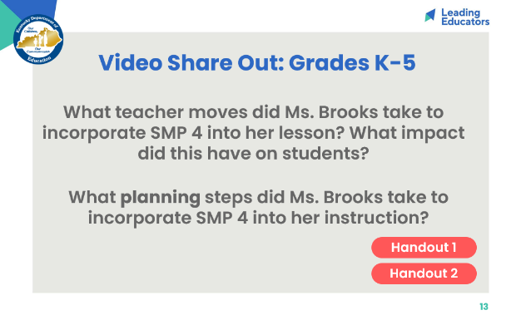
Slide 14:  (2 min) Teachers share their own experiences with utilizing SMP 4. Reflections from the video may prompt teachers to share their own best practices and consider adjustments/new learning based on the video. | 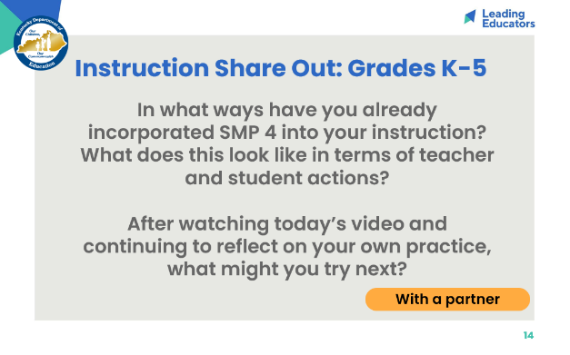
Slide 15:  (1 min) Allow teachers 1 minute to jot their reflection on their handout.  (3 min) Teachers share with an elbow partner or whole group. | 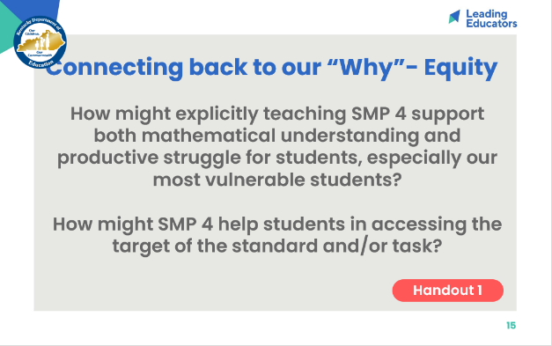
Slide 16:
(5 min) Teachers read aloud CFS - teacher and student look-fors. Provide teachers with an opportunity to discuss look-fors, connect look-fors to today’s session, and add look-fors.

*Note: Criteria for Success
- In the upcoming Reflection and Looking Ahead activity, ask teachers to select 2-3 indicators that they’d like to focus on as goals for this topic’s 3-week cycle.

Slide 17:  (5 min) Teachers complete reflection.  *Note: Facilitators may choose to  - Collect page 6 of Handout 1 as an artifact of teacher learning  - Have teachers bring this reflection to 1:1 coaching meetings  - Have teachers bring this reflection to future Planning & Practice and Student Progress sessions | 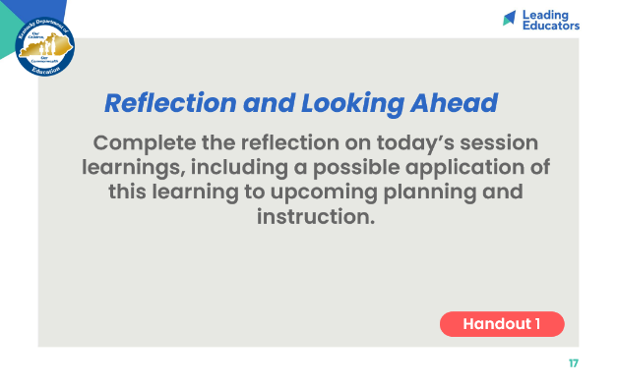
Slide 18:  (5 min) Facilitator says:  - “Take a moment to read our closing question; then I’d like for us to whip around and share our thoughts/build upon one another’s.”  - Teachers share out. | 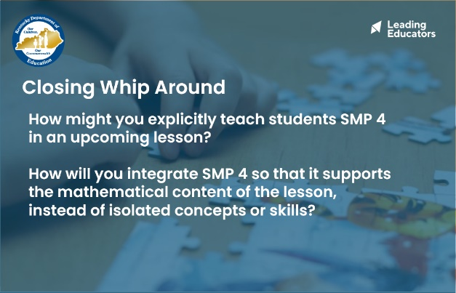
Slide 19:  (2 min) Facilitator previews next session and reminds teachers of any pre-work/action items to be completed before the next meeting. | 